**Kimberly Kuya Azure Cloud Disaster Recovery Practical Activity**

* The first step is to create a Windows 2016 Gen 1 Virtual Machine on Azure Cloud. To do that, open your Azure portal, hover on Virtual Machines and select Create.

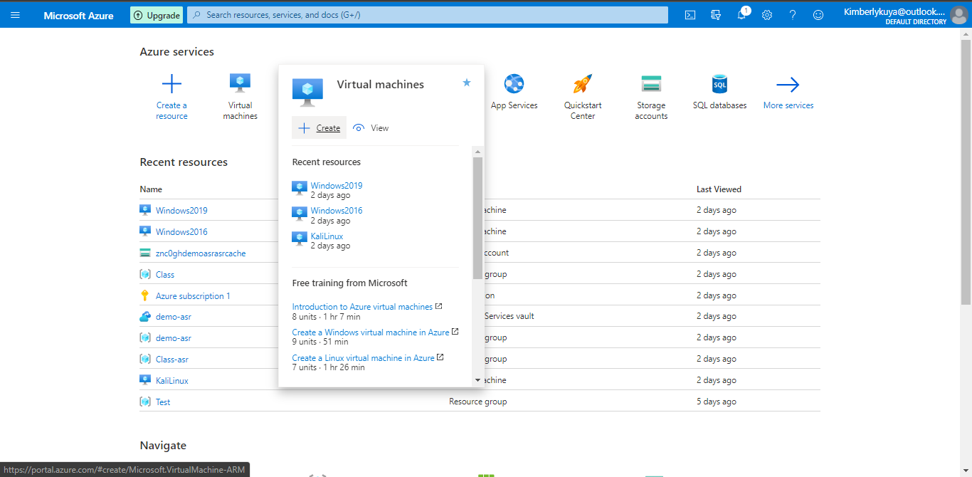

Fill in the appropriate details and select Review + Create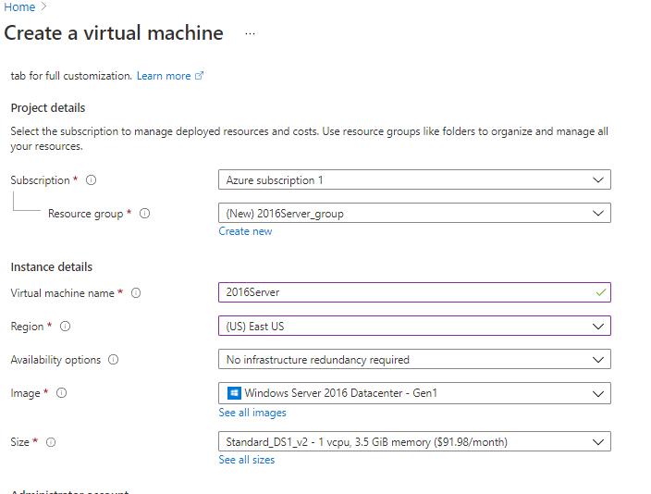

A successful deployment will present this screen then select ‘Go to resource’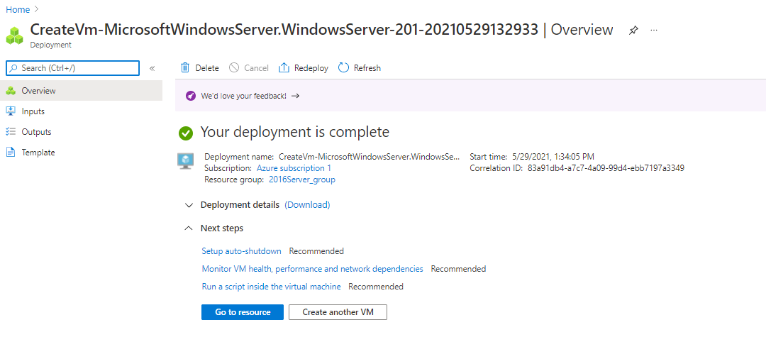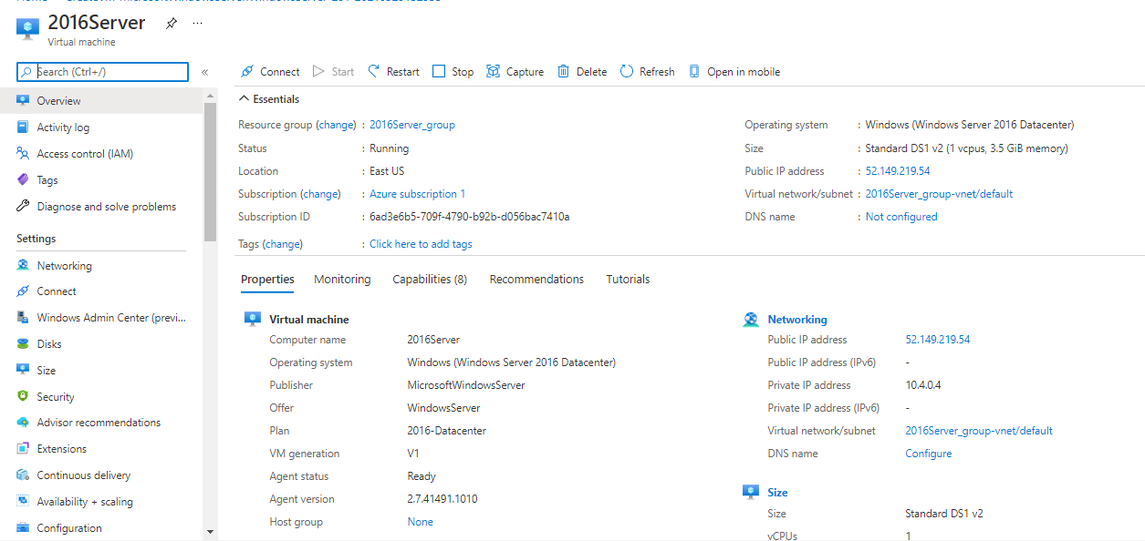

* The second step is install Web Server Management tools. Click Connect | RDP and download your RDP File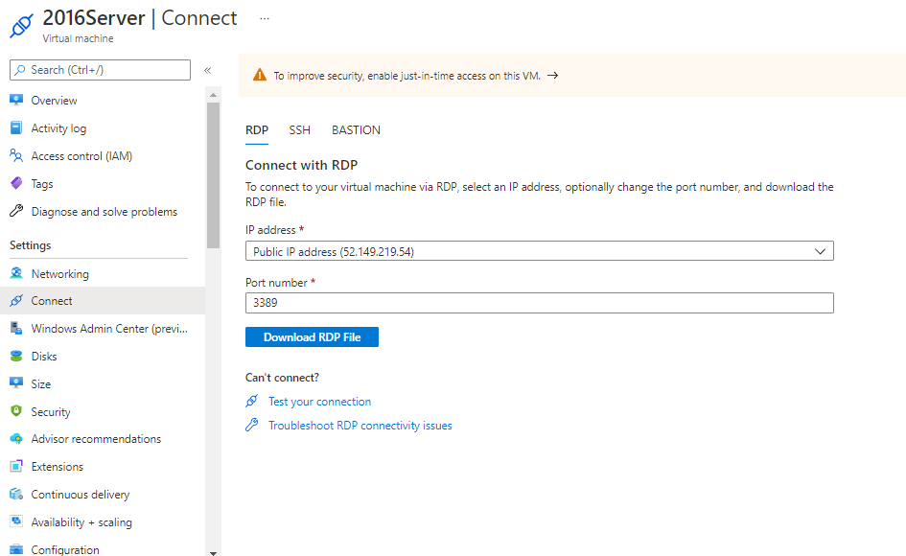

When you open your RDP File you will be prompted to enter your credentials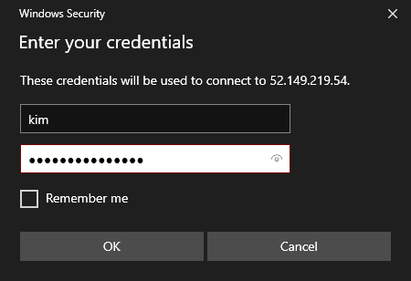

Once you’ve logged in successfully, from the server desktop, access Powershell and install the Web Management tools via **Install-WindowsFeature –name Web-Server -includeManagementTools**

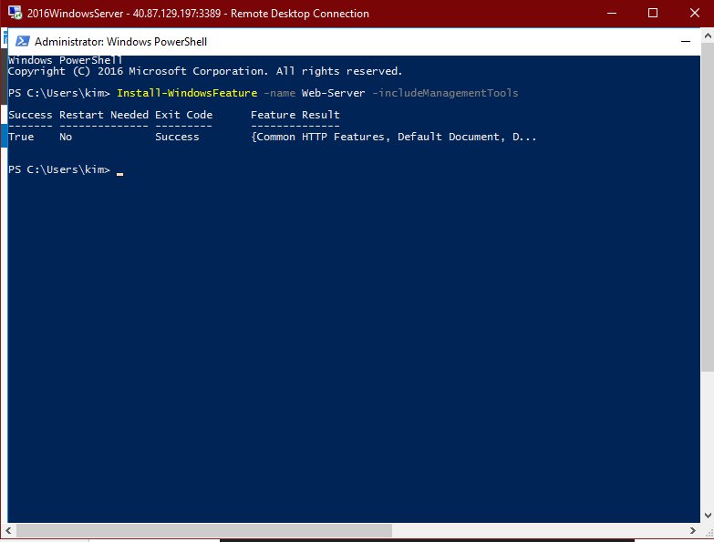

* Next, create a Site Recovery Vault. To do that, return to the Azure Portal, hover on the Recovery Service Vault and select Create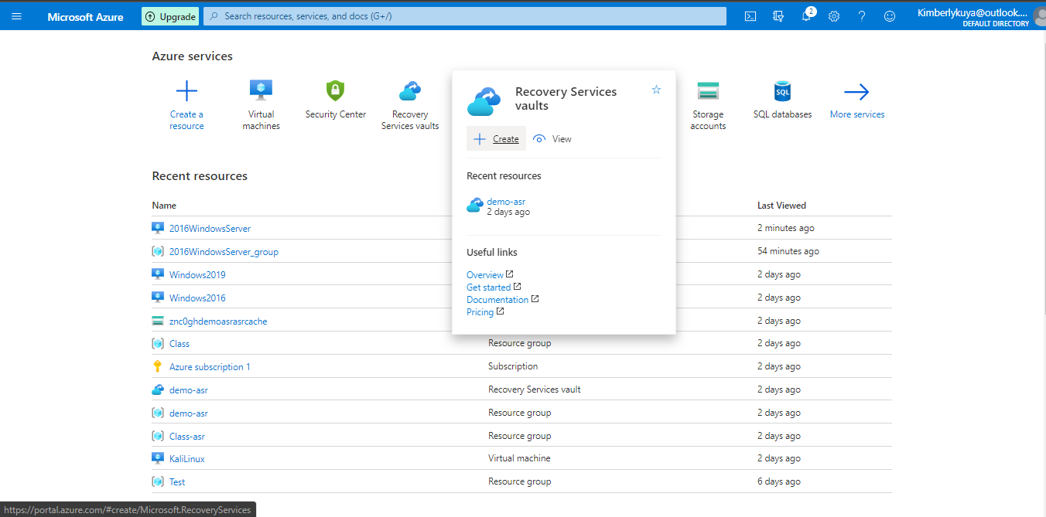

Fill in the correct credentials and select Review + Create 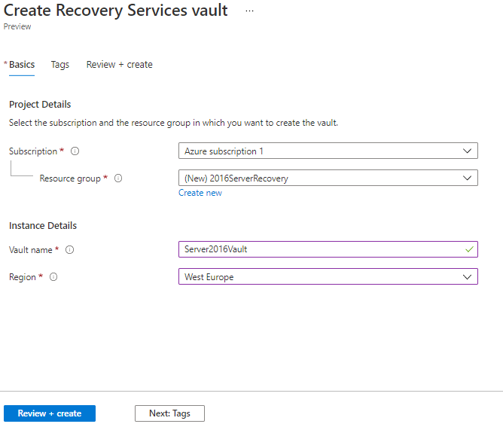

Once it is successfully deployed, you will be presented with this screen. Select go to Resource

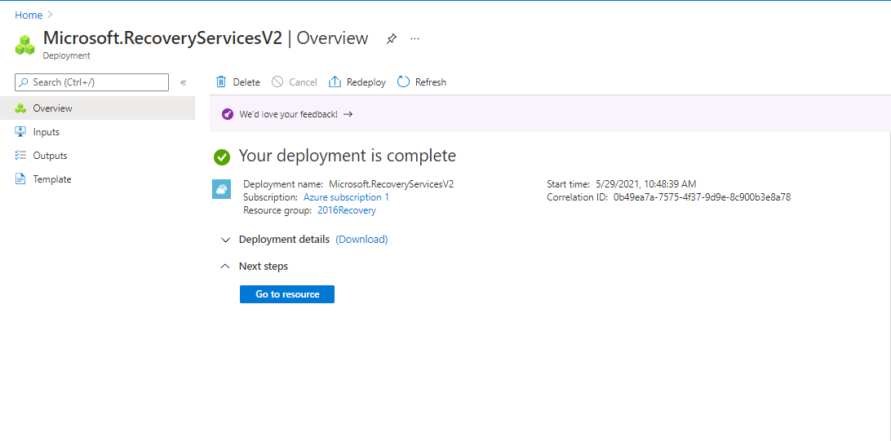

Select Replicated Items on the left hand side menu and click on the drop down menu of Replicate and select Azure machines 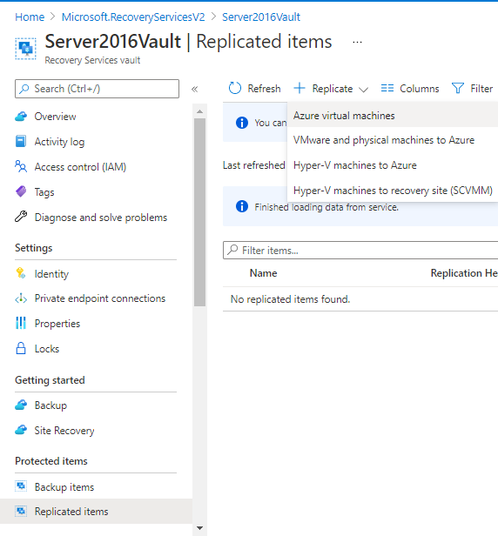

Fill in the correct information 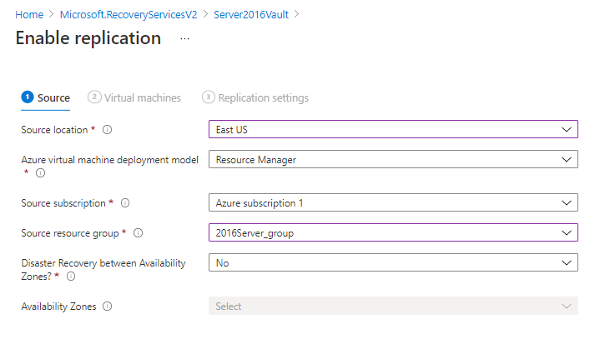 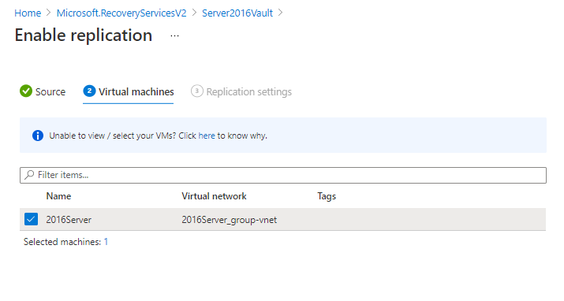

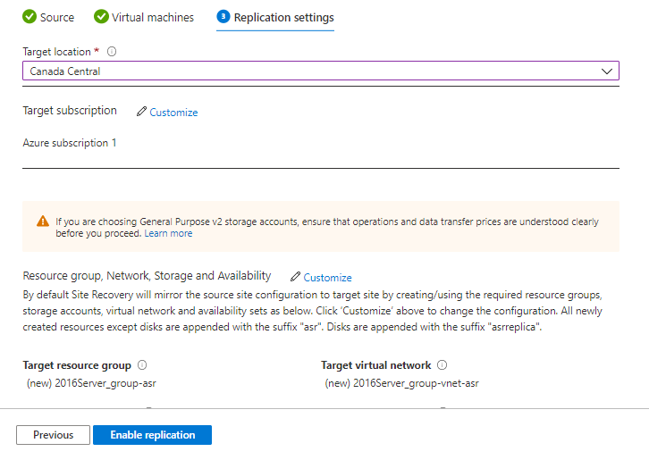

When you are done select enable replication

Once your device has replicated, it will appear in the replicated items list

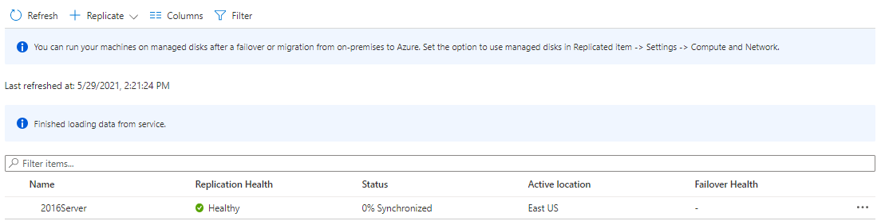

* Stop the VM from running so it simulates a breakdown 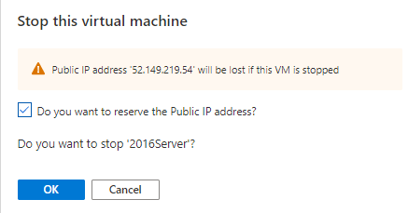
* Click the Disaster Recovery option from the left side menu and select Perform Test Failover 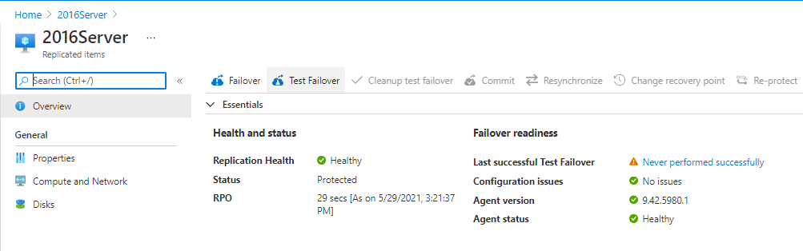

Ensure the details are correct and select ‘OK’ 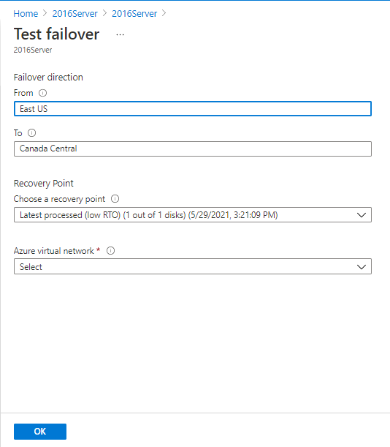

After a successful Test Failover, your screen should look like this

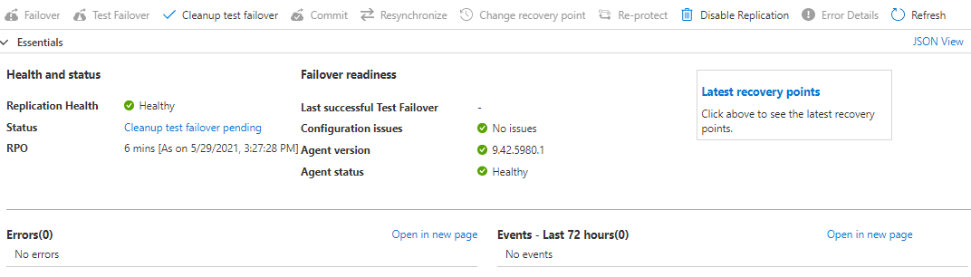

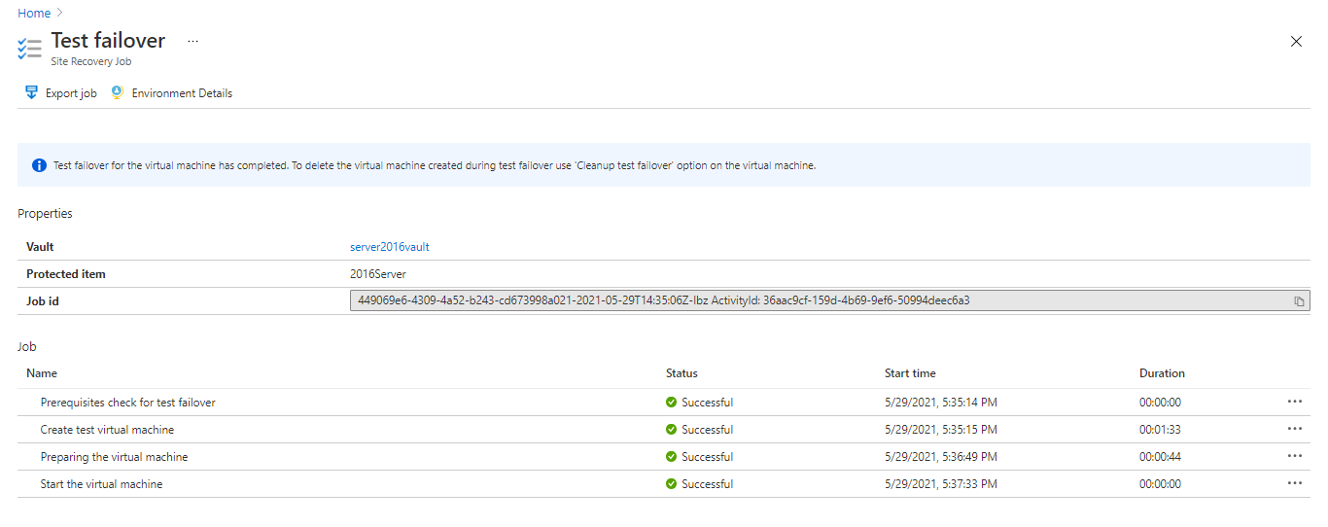

This is the test machine that is currently running in Canada as specified earlier

